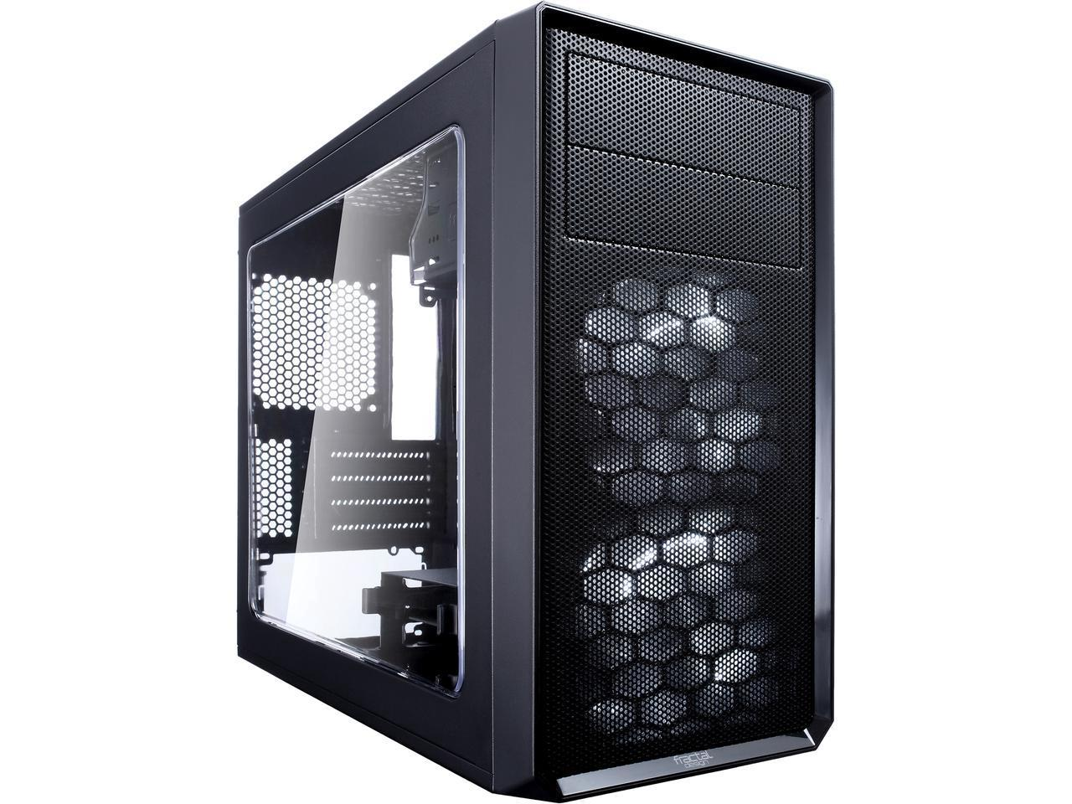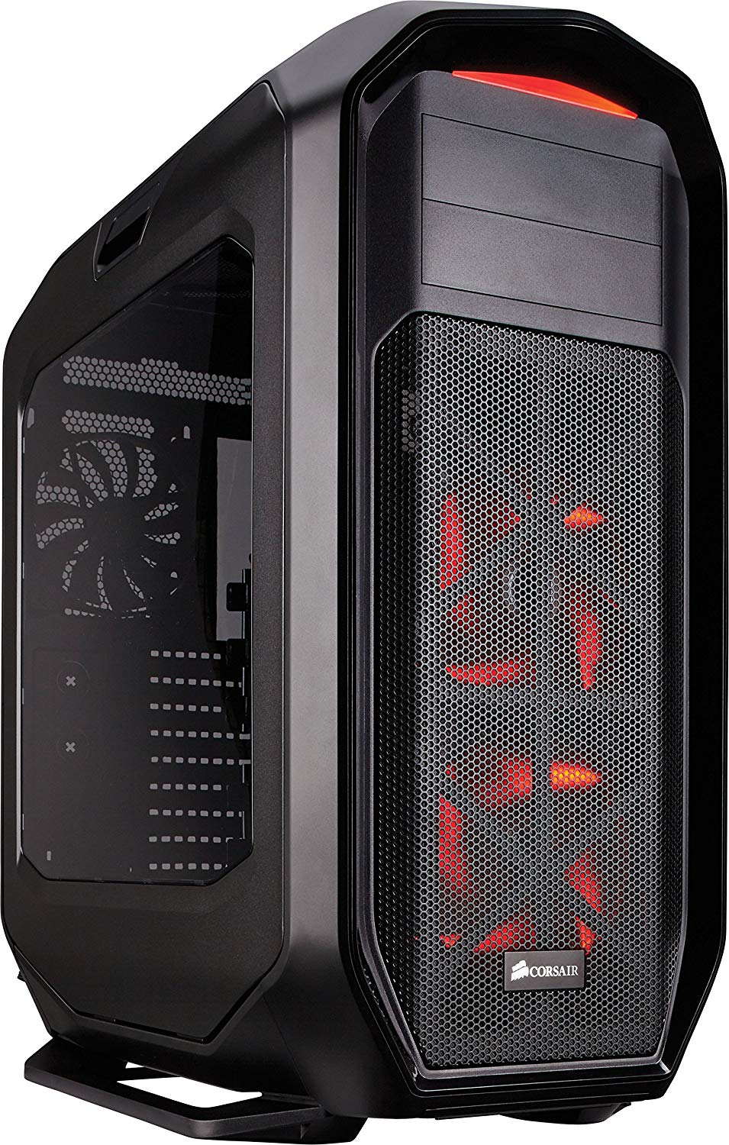

Photo editing Computer

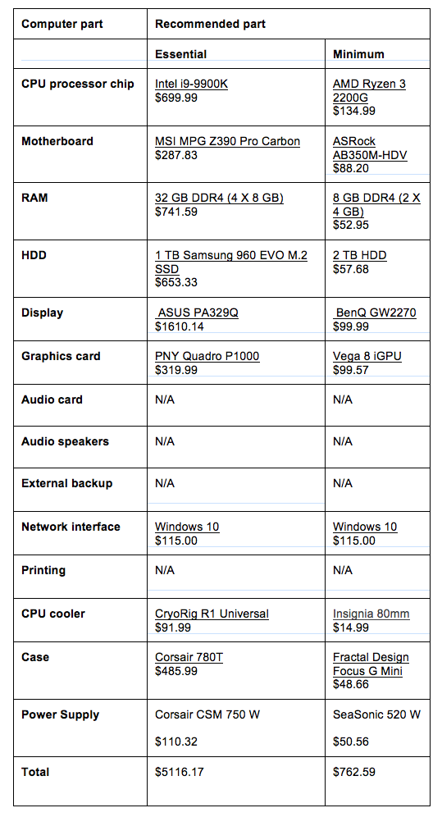

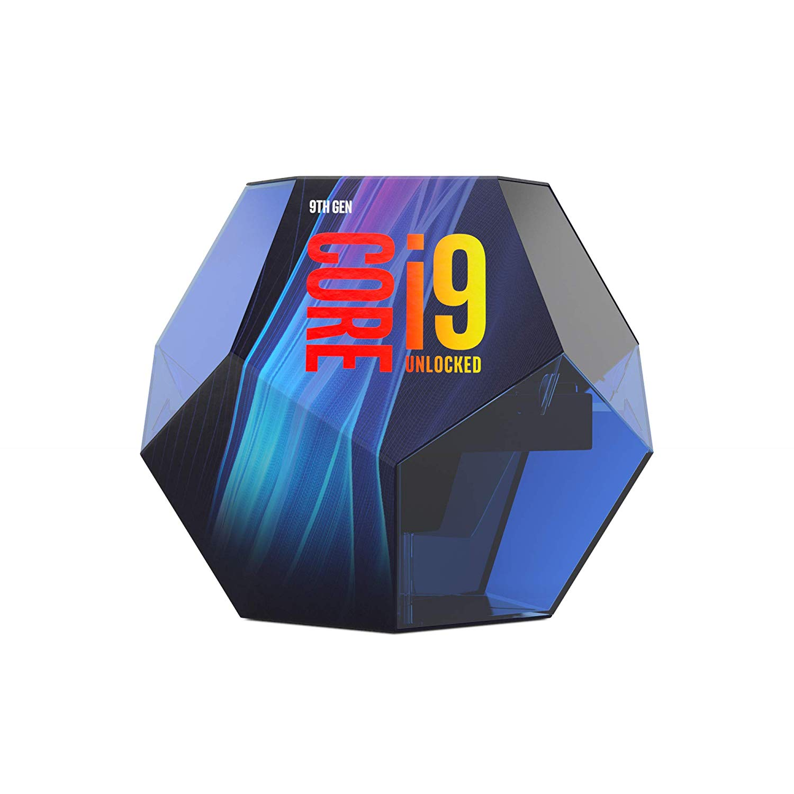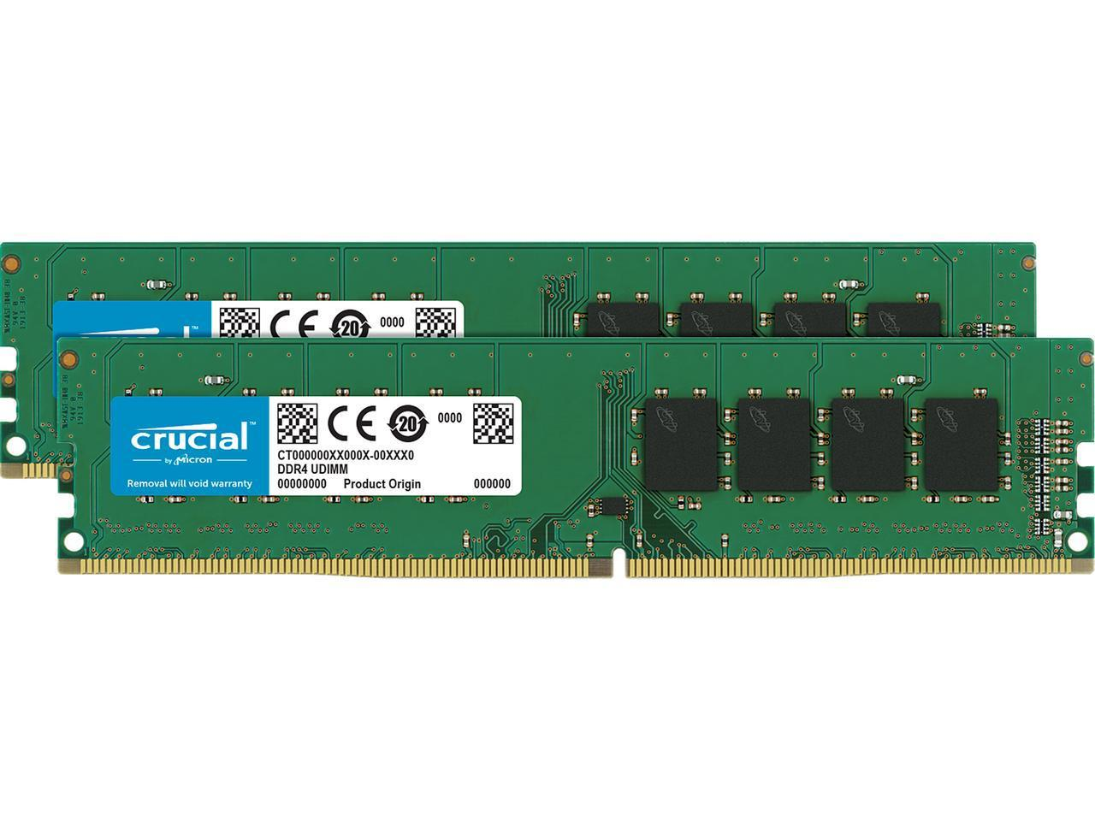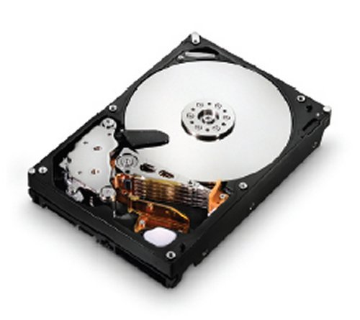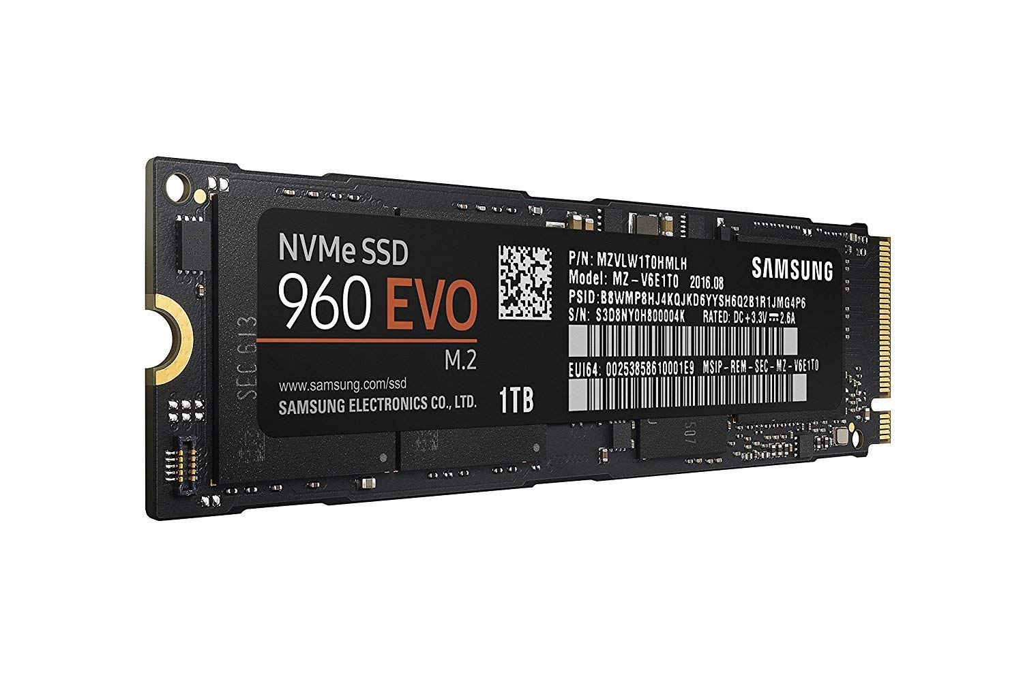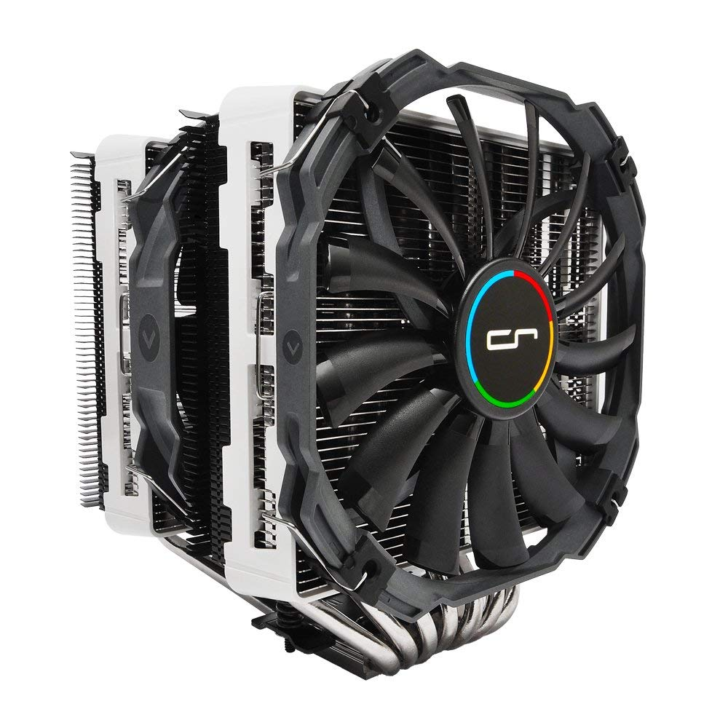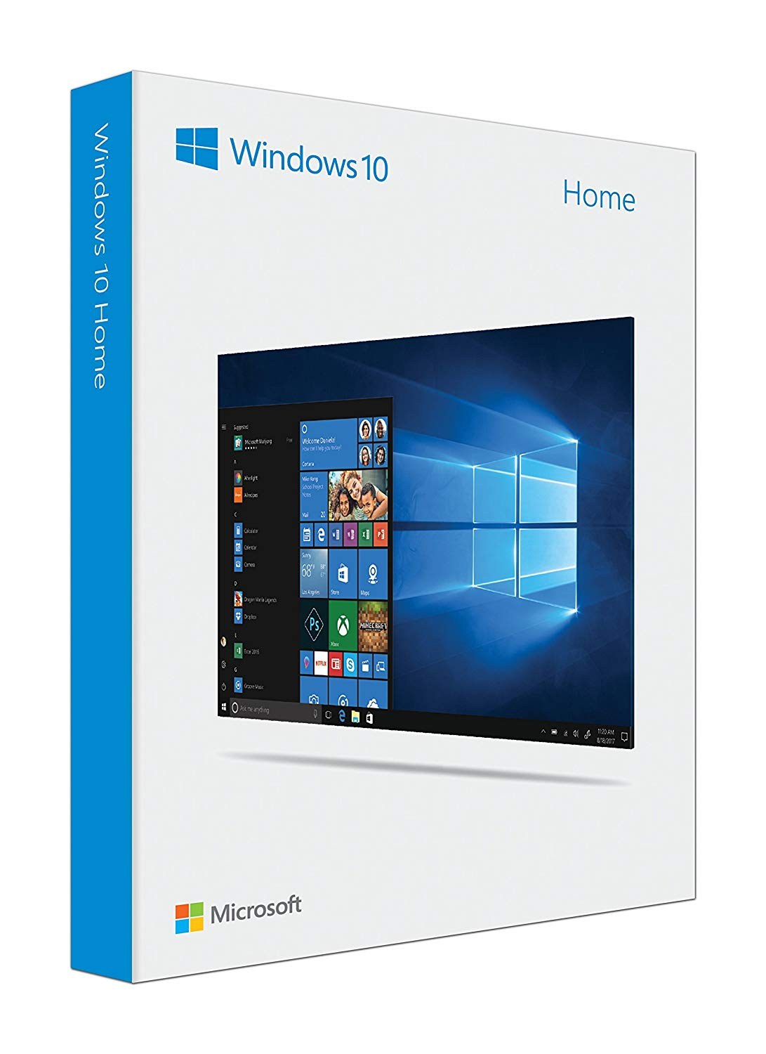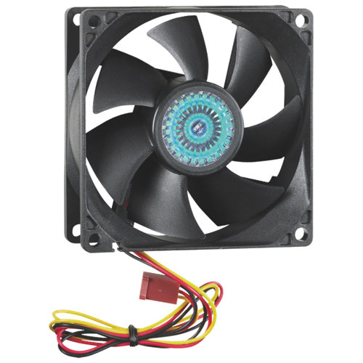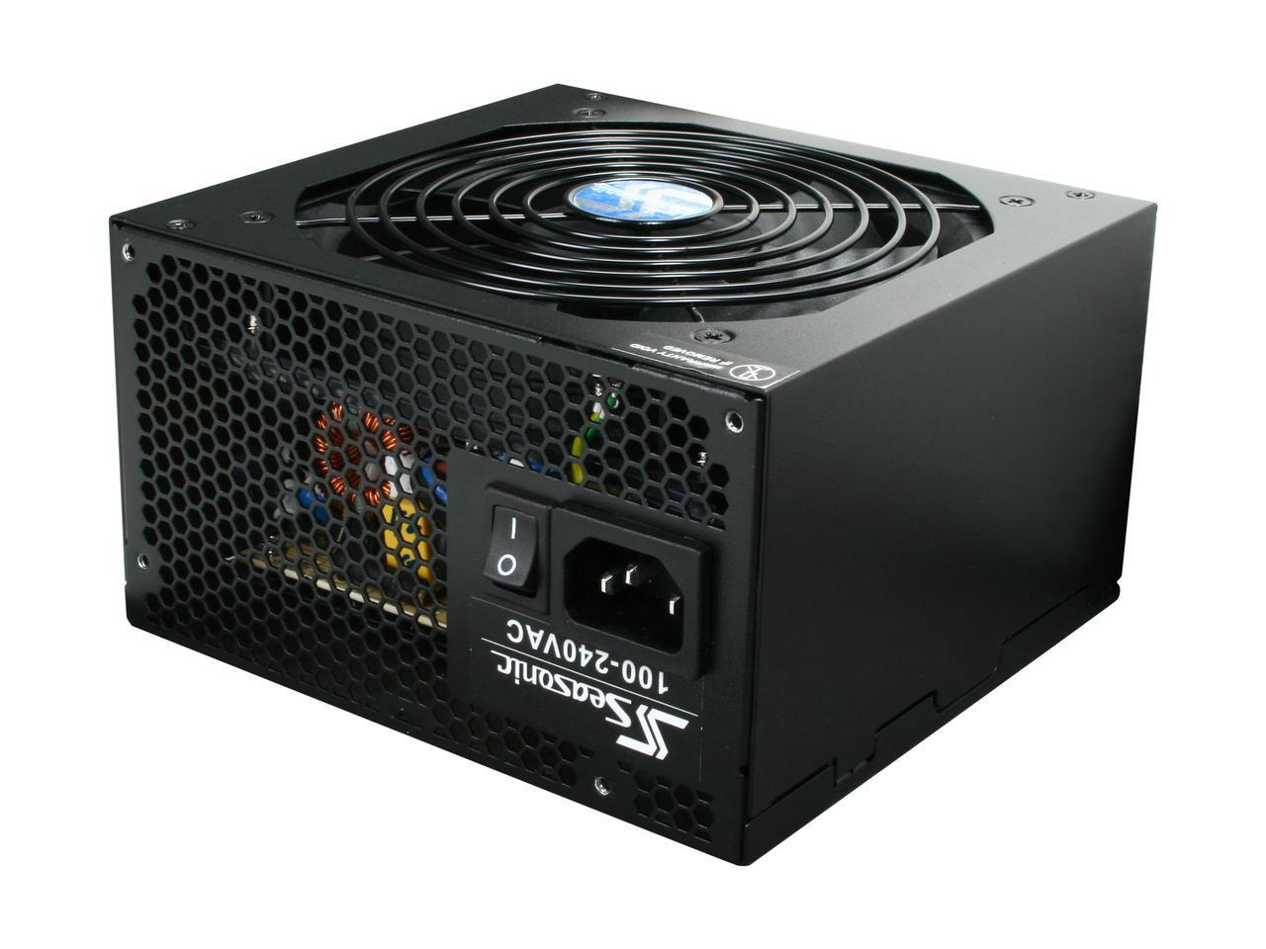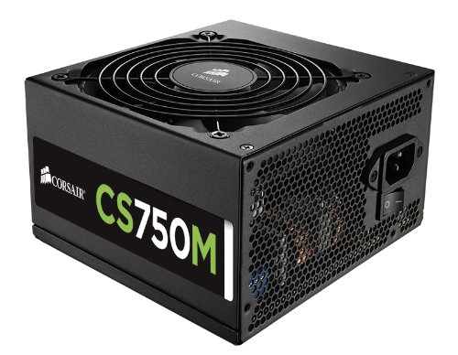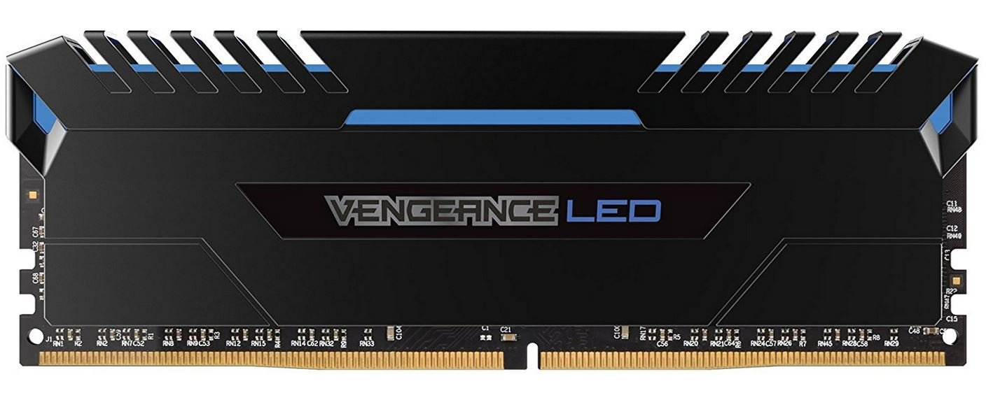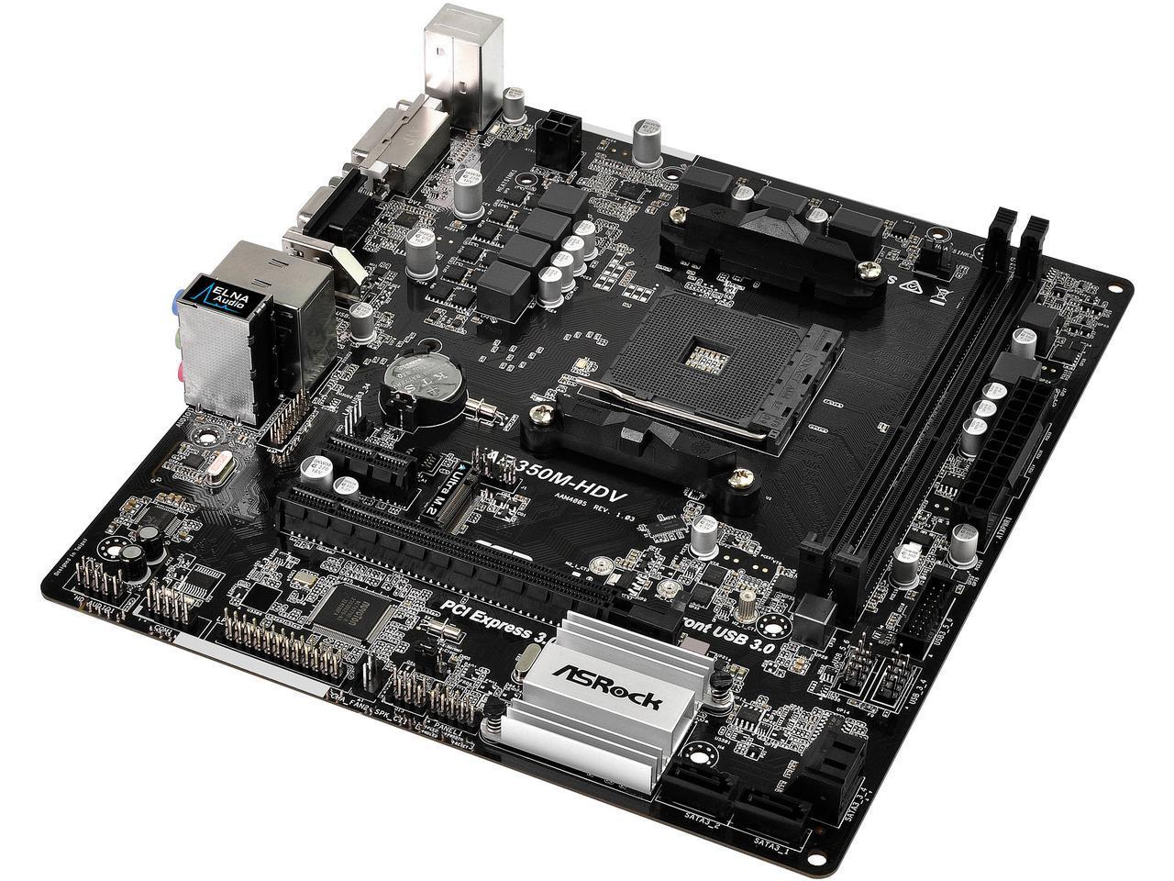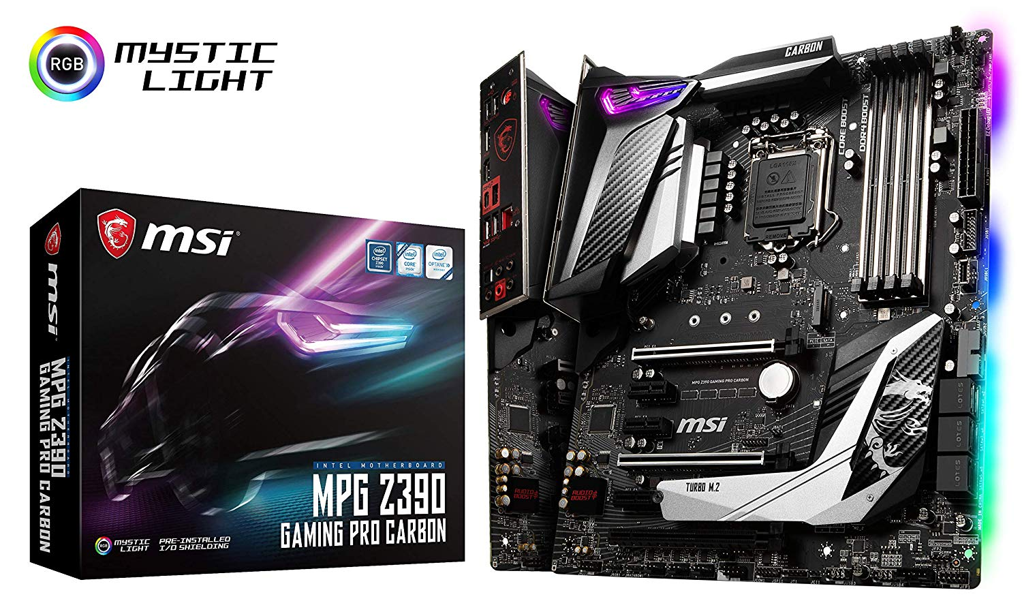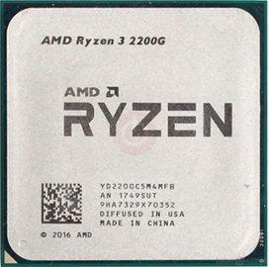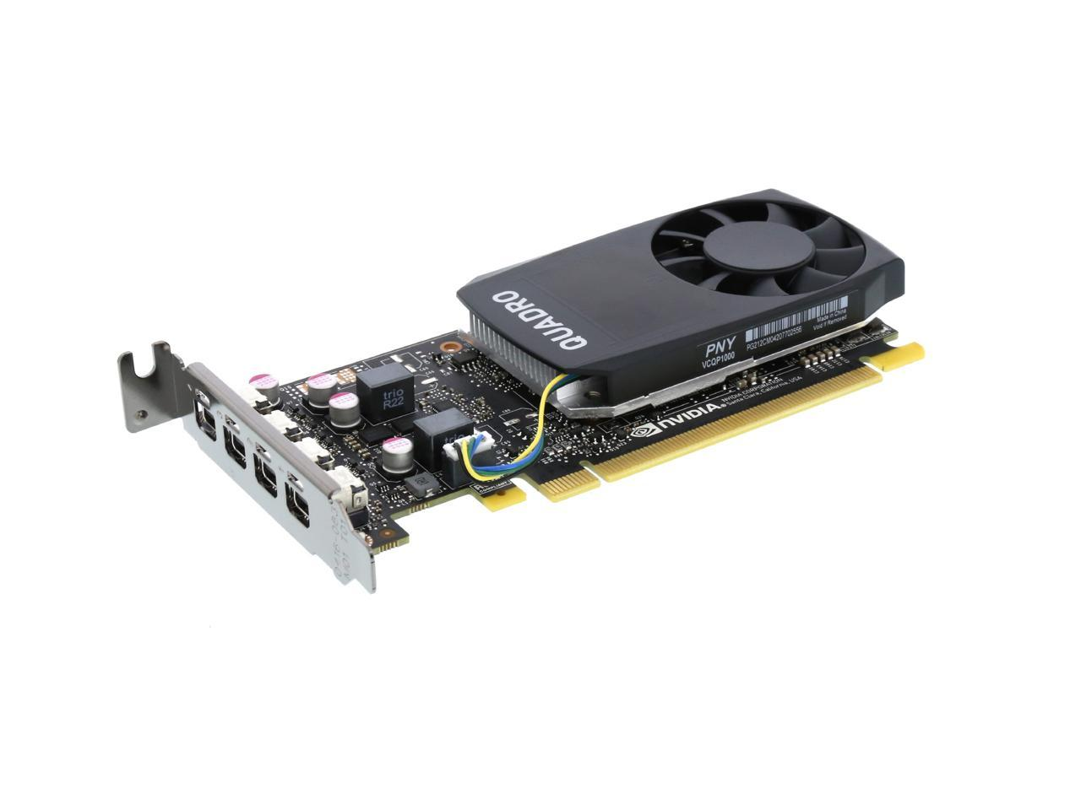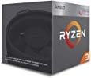

**$699.99 $134.99**

The CPU is the most important part of a computer. It’s primary job is editing and creating 2D work in photo editing and graphic design programs like photoshop. It is responsible for accomplishing all of the tasks that you instruct your computer to do during the normal course of a photo editing session.

**$319.99 $99.57**

Until you get a pricey card, it is unlikely that the typical photo editor or graphic designer will notice much of any improvement in their workflow brought about by upgrading their graphics card. Beyond (1) making sure that one’s build features a graphics card that can display 4K images on a 4K monitor and (2) making sure that one’s build has a reasonably balanced choice of discrete graphics card for its other components, one should feel comfortable being fairly conservative in choosing a graphics card.

**$287.83 $88.20**

The quality of a motherboard’s power features is a large part of what set an expensive motherboard apart from a cheap one. Quality motherboards usually possess more or better power phases (more isn't automatically better), solid capacitors, ferrite chokes, and MOSFET heatsinks are usually present in good-quality mobos. High-end motherboards may even have DrMos and tantalum capacitors.

**$741.59 $52.95**

RAM is not going to be one of your biggest concerns. Modern consumer systems all use DDR4 RAM. Most lower-end systems use dual-channel RAM, while the higher-end systems use higher-capacity dual-channel or quad-channel. A Dual-channel configuration provides slightly better performance than a single stick, and quad channel is slightly better than dual channel.

**$653.33 $57.68**

While any photographers reading this do not need this to be said, raw photographs can be massive files relative to other image files. Many professional cameras take photos with raw, uncompressed sizes well above 4K resolution. Given that this is the case, it is sensible to have enough hard drive space so that concerns over space will seldom or even never be a limiting factor on your work.

**$110.32 $50.56**

Getting a PSU that doesn’t support a sufficient wattage for your build, or (even worse) getting a budget PSU that may not have been well-made, increases the risk of catastrophic failure for your build. The specifications or numbers on the packaging don't tell the whole story, so unless you're an electrical engineer, the best way to find a good power supply is to ask an expert.

**$91.99 $14.99**

A heat sink and fan (HSF), also known as a CPU Cooler, sits atop the CPU to draw heat away from the CPU and disperse it, because CPUs produce heat while operating. Most CPUs will come with a free “stock” HSF; but if you buy a CPU that comes without a cooler and/or if you plan to overclock your CPU, you will need to buy an “aftermarket” HSF.

**$485.99 $48.66**

A case is a large box that holds all your components together securely. Case choices are subjective: the same case can be called ugly or beautiful depending on the viewer's taste. Recommendations are based on prices, features, and availability. A good case fits your hardware, has good airflow, is quiet, and is sturdy. Bottom-mounted PSUs and options for cable management are great bonuses.

**$115.00**

Windows 10 (32-bit) can run on a PC with 1 GB of RAM, but it runs better with 2 GB. For better performance, add memory so you have 3 GB or more. Windows 10 (64-bit) can run on a PC with 2 GB of RAM, but it runs better with 4 GB. For better performance, add memory so you have 6 GB or more.